

**Module Code & Module Title**

**CC4002NI Information Systems**

**Assessment Weightage & Type**

**30% Individual Coursework**

**Year and Semester**

**2018-19 Autumn**

**Student Name: Ayush Amatya**

**London Met ID: 18029908**

**College ID: NP01CP4A180129**

**Assignment Due Date: May 10, 2019**

**Assignment Submission Date: May 10, 2019**

*I confirm that I understand my coursework needs to be submitted online via Google Classroom under the relevant module page before the deadline in order for my assignment to be accepted and marked. I am fully aware that late submissions will be treated as non-submission and a mark of zero will be awarded.*

**Contents**

* **Table of Figures** 2
* **Table of tables:** 2
* **Introduction** 1
* **Discussion and Analysis** 2
* **Testing:** 7
* **Conclusion** 12
* **References** 13

# **Table of Figures**

Figure 1: introduction to web design (Young, 2012) 1

Figure 2: wireframe for home page 2

Figure 3: wireframe for CV 3

Figure 4: wireframe for blog 3

Figure 5: wireframe of feedback 4

Figure 6: wireframe of research 4

Figure 7: home page of my website 5

Figure 8: shrieked heading 6

# **Table of tables:**

Table 1: Blackbox test 1 8

Table 2 Black box test 2 8

Table 3 Black box test 3 9

Table 4 Black box test 4 10

Table 5 Black box test 5 11

# **Introduction**

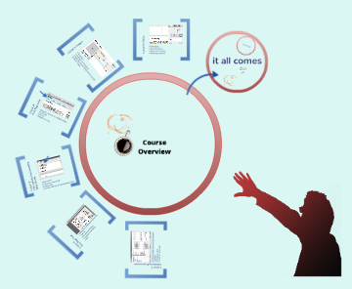This project report was done to develop a website consisting of at least 5 web pages where the impact of technology was discussed. Regardless about the impacts of technologies in our day to day life, this project report was mainly focusing on the development of a proper and well-structured website.

Figure 1: introduction to web design (Young, 2012)

A website is a collection of related network web pages. A website can be a personal website, a corporate website for a company and social networking to provide news and education. Websites can be accessed through a public IP network such as internet. There are many different application and methods to develop a complete website. However, the website developed in this project report was developed using simple basic application and programs. i.e. HTML, CSS and JAVA script. I also took help of an online design application which is Lucid Chart.(Holt, 2018)

HTML stands for Hyper Text Markup Language that describes the structure of webpages using markup. It is the building blocks of a website. HTML is used to highlight the core text and provide it a structure. CSS stands for Cascading Style Sheets. It decides how the html elements of a website should appear to the user and it also decides the position of the html elements. JavaScript is a complicated logic-based programming language that is used to modify website content and make it act differently are per the user’s actions and instructions. JavaScript is commonly used in confirmation boxes, calls-to-action and adding new identities. Java script is a full-on programming language that adds interactivity and functionality to a website. (@lkolow, 2016)

Lucid chart is an online digital media tool that allows the user to create an collaborate on charts, flowcharts, wireframes, etc. Wireframes serve as a layout for how a website will function and how users will navigate the site. Without wireframe, it is like building a house without a blueprint.(Wawrzyniak, 2017)

# **Discussion and Analysis**

Many technologies and applications were used to develop this simple website. This website is the combined result of all the small applications like HTML, CSS, JAVA SCRIPT and lucid chart.

Firstly, a wireframe was developed by the help of lucid chart to gain the basic idea about the structure of our website. The wireframe structure that I created for the design of this website are given below.

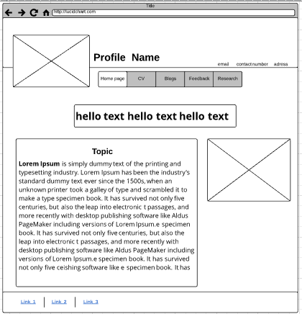

Figure 2: wireframe for home page

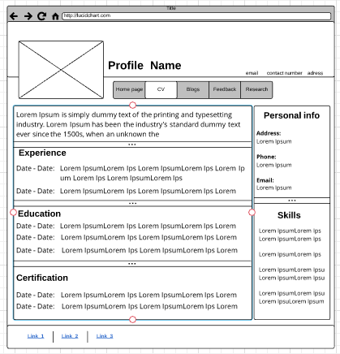

Figure 3: wireframe for CV

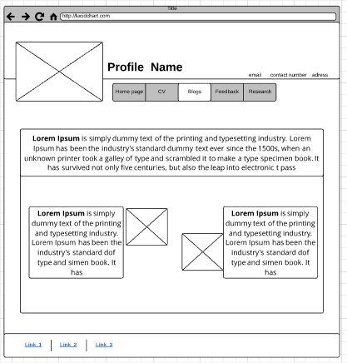

Figure 4: wireframe for blog

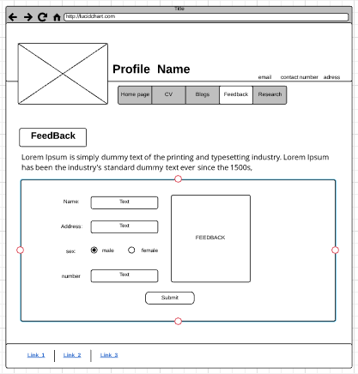

Figure 5: wireframe of feedback

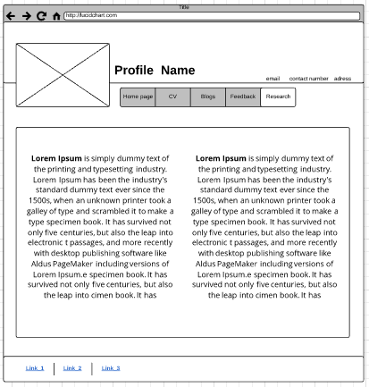

Figure 6: wireframe of research

After the completion of creating a wireframe, the codding in notepad++ was started. 1st the HTML was used to give the structure to the web page. Then CSS was used to give that element the position, design and different properties.

While giving the structure to the website, the header division was first separated as it will be included in every other webpage. According to that, the margin of the content was specified so that it is not blocked by the header.

The navigator bar is included in the header and the position was fixed so that the navigator bar always displays in the screen although the user scrolls the screen.

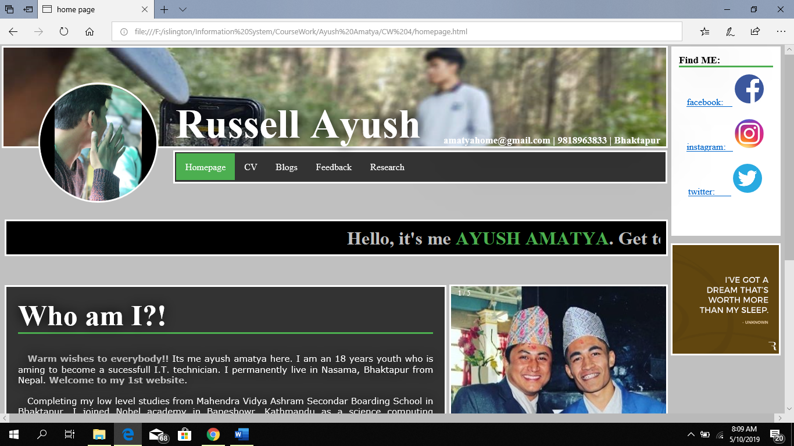

Figure 7: home page of my website

Above given screenshot is the homepage of my website. Here all the content above navigator bar including the right most column of social media link and motivational quotes are included in header portion as they need to be displayed in all the webpage.

The CSS design for the header part is written in “commonStyle.css” which is accessed by all the webpages.

For creating this website, I have created a total of 12 files. They are: commonScript.js, commonStyle.css, homepage.html, homepageStyle.css, cv.html, cvStyle.css, blog.html, blogStyle.css, feedback.html, feedback.css, research.html and research.css. All the files with extension “.html” include the structure code. All the files with extension “.css” include the design of the html element. And the file with “.js” includes the code of java script which is used in all the webpage.

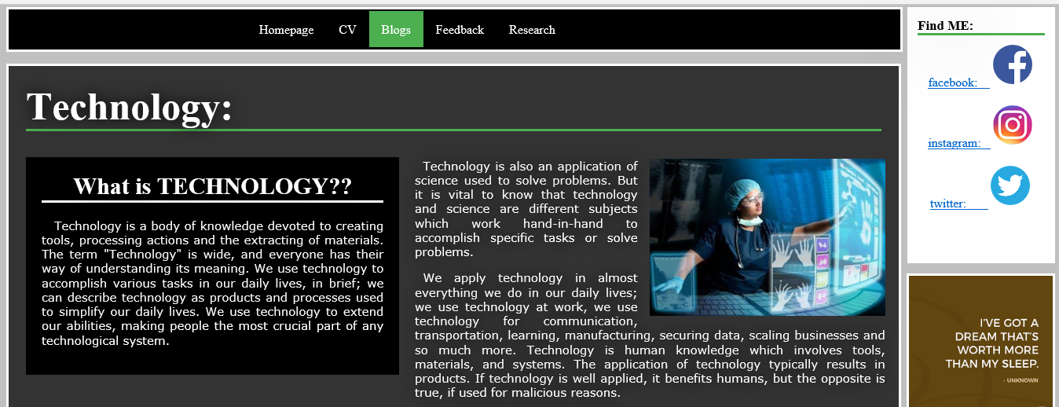

Figure 8: shrieked heading

In this webpage, the large header 1st displayed in the scree gets shrieked when the user scrolls the content. This is done using java script. Since it is to be implemented in all the pages, its code is written in commonScript.js which is latter accessed by all the files.

In the webpage that I developed in this course work consists the code of JAVA SCRIPT in 4 places. They are:

1. When users scroll the content, then the header shrinks.
2. I have created a gallery where the user can slide, the images using the pervious and next button.
3. I have created an auto sliding image which includes some motivational quotes. This auto sliding image changes its image in every time interval of 3 second.
4. I have inserted a form in feedback section which displays the error or success message whenever the user clicks submit button.

In this website, I have included 3 links (Facebook, Instagram and skype) through where the user can contact me.

# **Testing:**

The result for some of the black box testing done to check the correctness of my website are shown below:

1. Test to check the function of navigation bar:

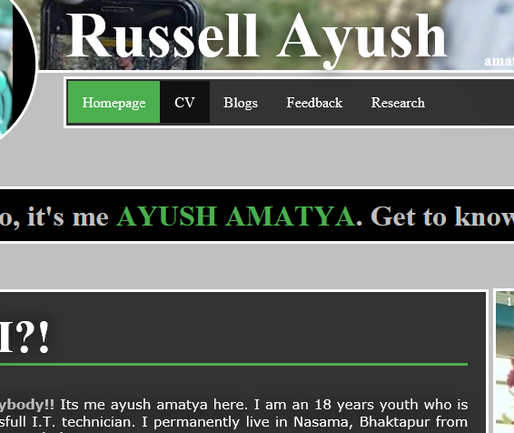

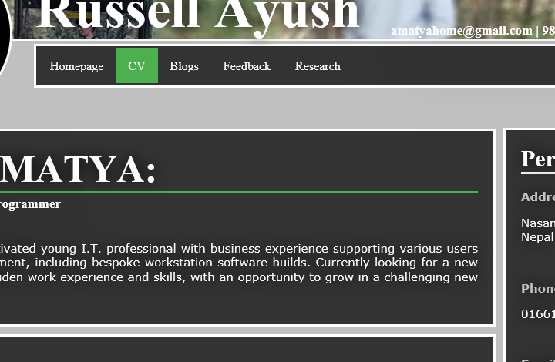

Table 1: Blackbox test 1

|  |  |
| --- | --- |
| Test number | 1 |
| Action | Click any tab on the navigation bar. |
| Expected result | The site should open the clicked page. |
| Actual result | The site opened the clicked page. |
| Test result | Pass |

1. Test to check whether the header shrinks while scrolling:

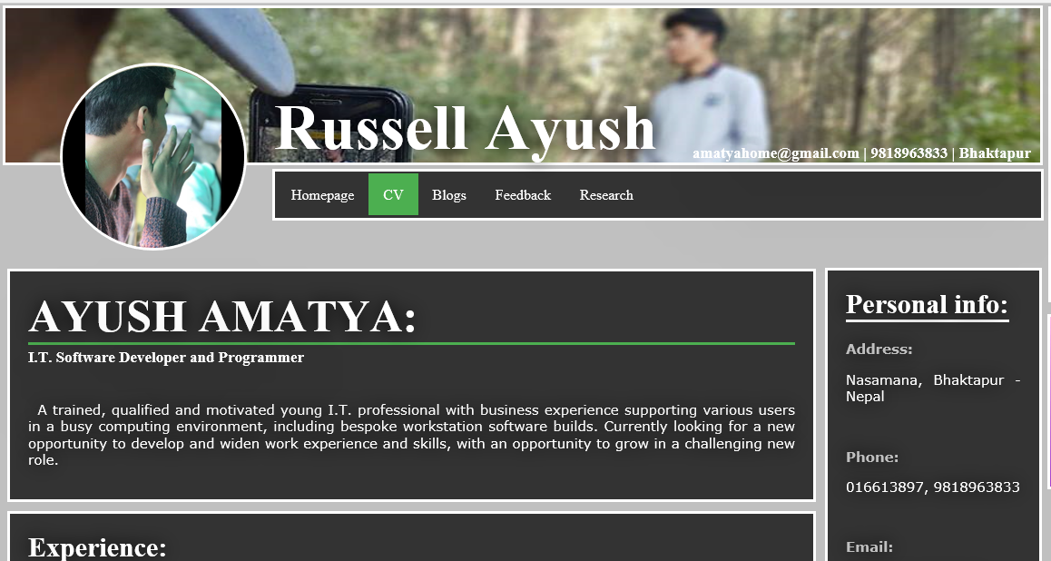

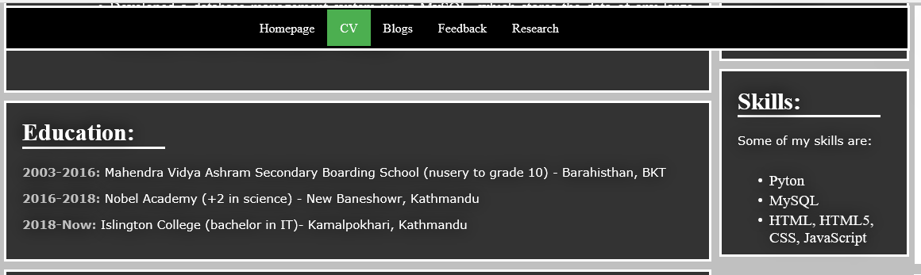

Table 2 Black box test 2

|  |  |
| --- | --- |
| Test number | 2 |
| Action | Scroll the webpage |
| Expected result | The large header should shrink to small header |
| Actual result | The large header shrieked to small header |
| Test result | Pass |

1. To check if the fixed header is working:

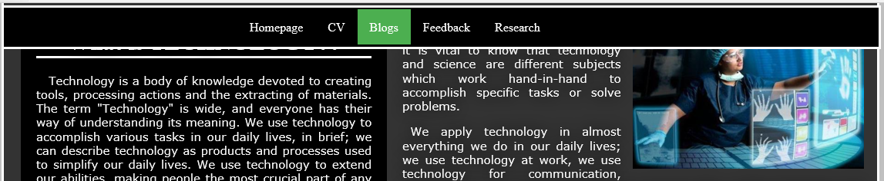

Table 3 Black box test 3

|  |  |
| --- | --- |
| Test number | 3 |
| Action | Scroll to the bottom of the page |
| Expected result | The content should go under the fixed header. |
| Actual result | The content went under the fixed header. |
| Test result | Pass |

1. To check the accuracy of feedback tab:

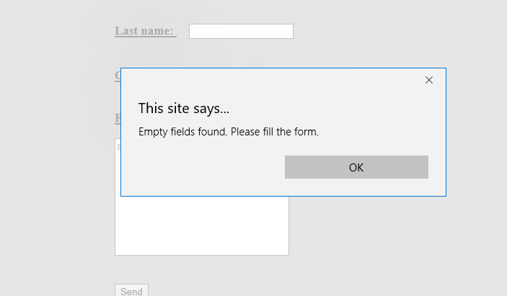

Table 4 Black box test 4

|  |  |
| --- | --- |
| Test number | 4 |
| Action | Try to submit an empty form |
| Expected result | Error message should appear |
| Actual result | Error message appeared |
| Test result | Pass |

1. To check the working of photo gallery:

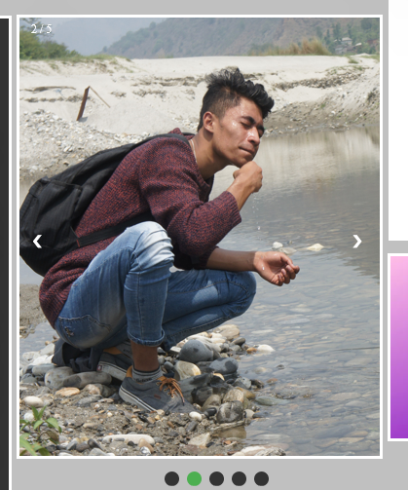

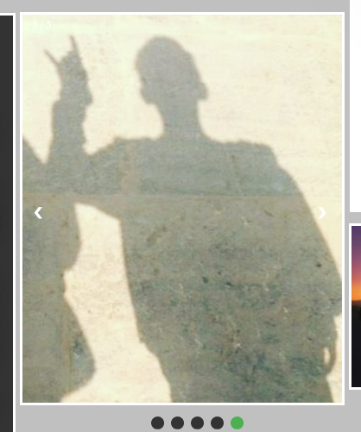

Table 5 Black box test 5

|  |  |
| --- | --- |
| Test number | 5 |
| Action | Click prev and next arrow of gallery box. |
| Expected result | The image should change as per the user’s instructions. |
| Actual result | The image changed as per the user’s instruction. |
| Test result | Pass |

# **Conclusion**

All the tasks assigned in the coursework was finally completed through much trial and errors. Finally, after complition of this project I have learn many new things. I am now able to develop a formal website interlinking many web pages. I have become fully aware about the positions of most of the html and css tags.

This coursework helped to improve ourself and get better in web development. Here we developed a comple websites just by using the basic applications i.e. HTML, CSS and Java script. Hecnce, now we are able to develop website throught all the other advanced web development application. It increase our skills and capacity of doing project in vast way. As per my knowledge, the tags that are most commonly used in developing a website are paragraph tag <p>, line break tag <br>, margin tag to specify the html content position and padding tag to make a text box attrative to the user.

By completing this given coursework, I am now familiar to lots of tags and their attributes with their uses. This helps me to make my webpage more attractive and user friendly. I have now stepped one step ahead to becoming a suceessfull I.T. texhnician.

It requires a nights of hardwork and must be determinant for better improvement. Even it was tough it was fun doing it. This project was sucessfully completed and all of the above mentioned aims and objectives were sucessfully achived. But their are again more things we must learn about web development in very vast ways. It feels great if our codes would be correct and program would run without bug and error.

# **References**

@lkolow. (2016) *hubspot* [Online]. Available from: <https://blog.hubspot.com/marketing/web-design-html-css-javascript> [Accessed 10 May 2019].

Holt, B. (2018) *frontendmasters* [Online]. Available from: <https://frontendmasters.com/teachers/brian-holt/> [Accessed 10 May 2019].

Wawrzyniak, E. (2017) *A Medium Corporation* [Online]. Available from: <https://medium.com/dslab/diagramming-with-lucidchart-ee53f61102fc> [Accessed 10 May 2019].

Young, D. (2012) *msu* [Online]. Available from: <https://msu.edu/~youngdeb/WebDesign/index.html> [Accessed 10 May 2019].